ASR 4743 Request:

Scope Description:

To capture the 2nd user ID who weight / update package dimension

To display the data in pack entry and packed detail report.

FromJack:

Due to need forklift to lift the pallet to the weighing machine, and most packers (1st packer) do not drive forklift. So weighing will be done by forklift driver (2nd packer).

Yes, I will need to know the last person who updated the dimension and weight.

**From:** Jack, Fong   
**Sent:** Wednesday, 10 September, 2014 3:48 PM  
**To:** Chan, Pei-Fong  
**Cc:** Zhi Ai, Huang; Ping He, Huang  
**Subject:** Tracking staff for update of Weight and Dimension

Hi Pei Fong,

Would like to check with you if an enhancement to WMS RF Packing can be made.

To perform packing, our packing staff logs in his own ID in RF, and performs packing (A).

After packing is completed, staff will update weight and dimension, as per (B).

However, due to weighing machine constraint, the packing staff may only complete packing, and only update the dimension.

As for weight, it may be updated by another staff.

(B)(A)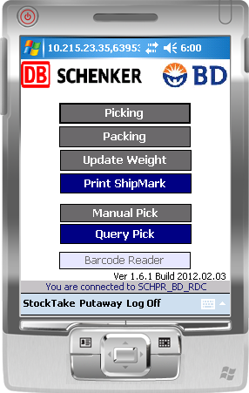

The issue here is we are not able to trace the 2nd staff who updates the weight, as we can only see the name of the 1st packer.

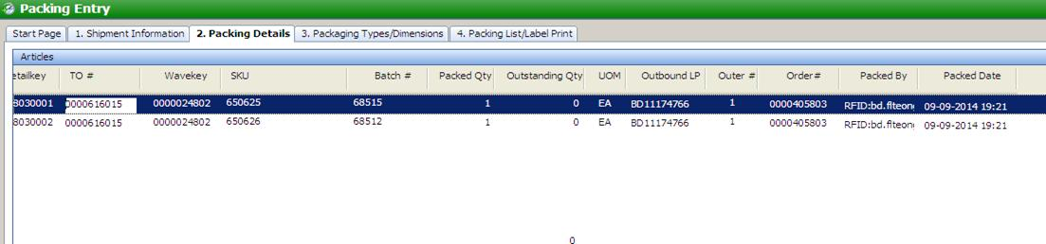

Are we able to also have the screen to show the person who update the weight and dimension?

Maybe another column to show “edited by”?

Thanks and Best Regards,

Jack FONG (Mr)

Assistant Manager

Contract Logistics/SCM, Operations

Schenker Singapore (Pte) Ltd

Tuas Logistics Centre

5 Tuas View Lane, Singapore 637291

DID: +65 6795 0316

Mobile: +65 9734 2700

WMS CHANGES:

Pack Entry:

Add weight by and weight date

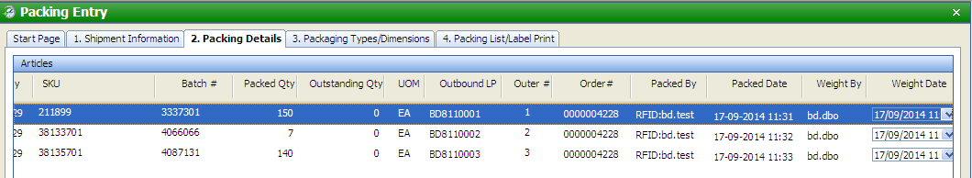

Finalized packed detail report:

